Grading Document - Lab 3

For your grading of lab 3.

## Pre Lab

1. What does the Fast Fourier Transform (FFT) do?
   * 1. Answer: The FFT, in most basic and simple terms, finds the sine waves that make up a signal (if we represented the signal as a collection of sine waves) ([ref](https://simple.wikipedia.org/wiki/Fourier_transform)).
   1. If we used FFT on a signal, what would it tell us?
      1. Answer: It would tell us the frequencies of the sine waves in the system and their magnitudes ([ref](https://simple.wikipedia.org/wiki/Fourier_transform)).
2. Passive Filters
   1. Describe what a low-pass, high-pass, and band-pass filter do. Provide circuit diagrams for each filter. What is the cutoff frequency equation for each filter?
      1. Answer: (needs to include diagrams and equations)
         1. Lowpass - only allows frequencies under the cutoff frequency to pass through the filter ([ref](https://www.allaboutcircuits.com/textbook/alternating-current/chpt-8/low-pass-filters/)).
         2. Highpass - only allows frequencies higher than cutoff frequency to pass through filter ([ref](https://www.allaboutcircuits.com/textbook/alternating-current/chpt-8/high-pass-filters/)).
         3. bandpass - combo of lowpass and highpass, making a window of frequencies that are allowed through ([ref](https://www.allaboutcircuits.com/textbook/alternating-current/chpt-8/band-pass-filters/)).
   2. What is the cutoff frequency?
      1. Answer: the frequency at which 3dB is lost in the filter (aka 70.7% of input voltage remains) ([ref](https://www.allaboutcircuits.com/textbook/alternating-current/chpt-8/low-pass-filters/)).
3. Interrupts
   1. Describe what an Interrupt does. **How does it differ compared to what we have been doing so far (known as polling)**?
      1. Answer: ([ref](http://www.engblaze.com/we-interrupt-this-program-to-bring-you-a-tutorial-on-arduino-interrupts/), [ref](https://www.allaboutcircuits.com/technical-articles/using-interrupts-on-arduino/))
         1. An interrupt will pause the code and run immediately when some condition has been met on a certain pins built into the arduino uno.
         2. This differs from before because we have had to check the pin in the past ourselves manually every time, but this is more automatic.
   2. What are the advantages of using interrupts?
      1. Answer: Interrupts run immediately and you don’t need to do anything about them in loop ([ref](http://www.engblaze.com/we-interrupt-this-program-to-bring-you-a-tutorial-on-arduino-interrupts/), [ref](https://www.allaboutcircuits.com/technical-articles/using-interrupts-on-arduino/)).
   3. What pins can you set up for an interrupt on the Arduino Uno?
      1. Answer: Pins 2 and 3 will work on the UNO. This translates to interrupts 0 and 1 for the attachInterrupt function, respectively. ([ref](https://www.arduino.cc/reference/en/language/functions/external-interrupts/attachinterrupt/))
   4. What is the function that sets up an interrupt in the Arduino coding language?
      * 1. Answer: The attachInterrupt function sets up an interrupt for the arduino. ([ref](https://www.arduino.cc/reference/en/language/functions/external-interrupts/attachinterrupt/))
      1. What parameters does it take in? What do they do?
         1. Answer: The attachInterrupt takes in three parameters ([ref](https://www.arduino.cc/reference/en/language/functions/external-interrupts/attachinterrupt/)):
            1. The interrupt - indicate which pin the interrupt is occuring on.
            2. ISR - the name of the function you want to happen when the interrupt triggers
            3. trigger - indicate what you want the interrupt to trigger on, a RISING (Low to High) signal, a FALLING (High to Low) signal, or both (CHANGE)

## Discussion Questions

1. **Discussion Question 1:** Check your timestamps between samples. What is the actual sample rate based on the average distance between time samples?
   1. Answer: The frequency is not 1000 per second (despite the delay) and it can depend immensely on how they implemented things in Arduino. Typically, you can expect something around the order of 33Hz.
2. **Discussion Question 2:** What is the effect of the moving average on your signal response?
   1. Answer: It makes the arduino less responsive to change, which increases the response’s lag present in the system. It makes a smooth graph though.
3. **Discussion Question 3:** What is the highest number of averaged samples you would be comfortable using for this scenario?
   1. Answer: Depends on their data. Expect 10 or 25 as the typical answer.
4. **Discussion Question 4:** What is the resistance of the internal resistor in the chip?
   1. Answer: 32 kΩ
5. **Discussion Question 5:** What is the equation for the 3dB bandwidth?
   1. Answer: There are two acceptable answers, both from page 11.
      1. f = 1 / ( 2 * pi * 32kΩ * C)
      2. f = 5 uF / C
6. **Discussion Question 6:** What is the minimum capacitance recommended? What is the calculated frequency bandwidth?
   1. Answer:
      1. Part (1) Minimum capacitance is 0.0047 uF (from page 11)
      2. Part (2) The calculated frequency bandwidth is about 1064 Hz.
7. **Discussion Question 7:** What is the built in capacitance? What is the calculated frequency bandwidth?
   1. Answer:
      1. Part (1) Built in capacitance is 10 nF.
      2. Part (2) The calculated frequency bandwidth is 500 Hz.
8. **Discussion Question 8:** How does each filter affect your accelerometer response?
   1. Answer: From their data.
9. **Discussion Question 9**: Which is the best condition to use for the interrupt: FALLING, CHANGING, or RISING?
   1. Answer: There is no perfect answer here. Look for a coherent argument.
10. **Discussion Question 10**: What is the count after those 50 presses?
    1. Answer: From their data.
11. **Discussion Question 11**: What is the count after 20 presses?
    1. Answer: From their data.
12. **Discussion Question 12**: What is the count after those 50 presses?
    1. Answer: From their data.
13. **Discussion Question 13**: What is the best debouncing time? Back it up with your data.
    1. Answer: The best debouncing time is based on their data. You can typically expect 100 to work the best. Some groups try to find values in between the values given, that should be fine.

## Report Questions

1. In the last few labs we used sensors that were noisy. Now you will post process the data gathered from Lab 1 with a moving average filter (see [here](https://www.mathworks.com/help/matlab/ref/movmean.html)) in matlab.
   1. For your results from both sensor, filter the data with 10, 25, 50, 100, and 1000 samples for your moving average filter. Plot all of the responses with the raw response in matlab. What is the result? What is the largest amount of samples you are comfortable with using for each sensor?
      1. Answer:
         1. They should include the plots. Here’s what to expect:
            1. 10 - smooths data for temp and light
            2. 25 - smooths data for temp and light, more than 10
            3. 50 - smoothed data for temp (but too smoothed), really starts to mess with the signal for light
            4. 100 - same as 50, but to a greater degree
            5. 1000 - straight line for both
         2. These are plots from a student from last year with good data, as a reference:

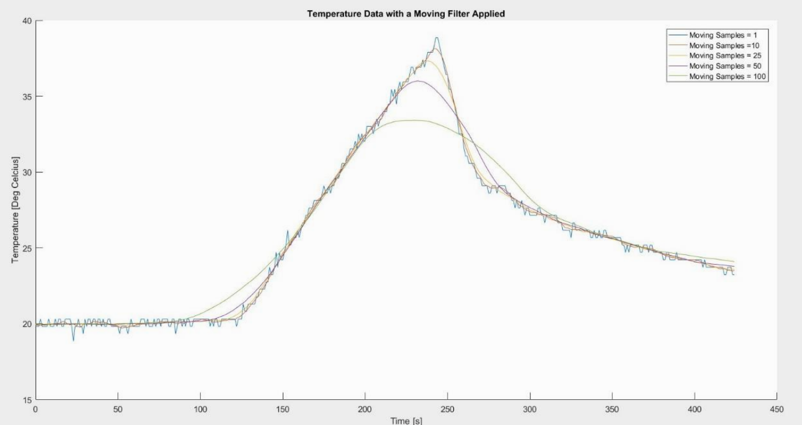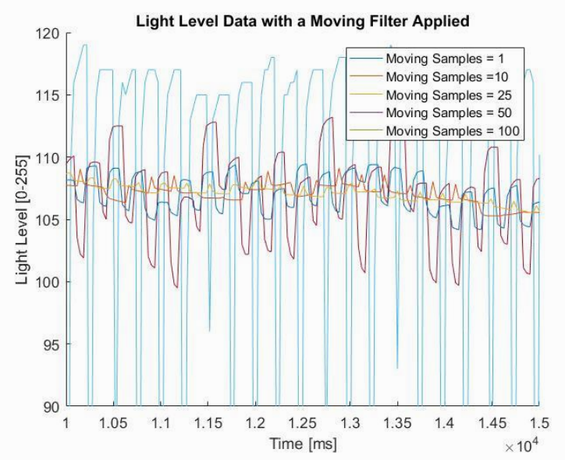

1. Compare and contrast between the software and hardware filtering techniques for sensor filtering. What are the advantages and disadvantages of both?
   1. Answer: I will list some acceptable common answers.
      1. Software filtering:
         1. Advantages:
            1. Nothing extra needs to be built
            2. Easy to change and configure
         2. Disadvantages:
            1. Extra stuff to run in your code (higher computational load)
      2. Hardware filtering:
         1. Advantages:
            1. Entirely passive from a code perspective, no extra code complexity

Can add it a system after the fact without changing the rest of the system

* + - 1. Disadvantages:
         1. Another piece of hardware, more wires
         2. Less easy to change once its made permanent (soldering the filter together, etc)

1. In this lab we implemented passive hardware filters. What are active hardware filters? How do they differ from passive filters? What exactly makes them active? What is an instrumentation amplifier?
   1. Answer: ([ref](https://www.allaboutcircuits.com/video-lectures/op-amp-active-filters/))
      1. *Note:* We don’t expect them to get all of the electronics knowledge perfectly right, nor do we expect them to give a separate answer for each subquestion. But for sake of completeness, I will.
         1. Active hardware filters are filters that actively filter the system.
         2. They differ from passive filters because they need to be powered.
         3. They are made active with an op amp.
         4. An instrumentation filter is a setup with three op amp that amplifies a signal and filters out noise at the same time ([ref](https://www.allaboutcircuits.com/textbook/semiconductors/chpt-8/the-instrumentation-amplifier/)).
2. Describe what’s the difference between polling and interrupts. Make up your own polling vs interrupt analogy, similar to the example provided in the links provided for prelab.
   1. Answer: Interrupts trigger right away, polling will only check the state of the pin at the time of the digitalRead, meaning that you can miss a signal if your timing is bad ([ref](http://www.engblaze.com/we-interrupt-this-program-to-bring-you-a-tutorial-on-arduino-interrupts/), [ref](https://www.allaboutcircuits.com/technical-articles/using-interrupts-on-arduino/)).
      1. Make sure their analogy makes sense. The example used in the link provided was watching a movie and waiting for the UPS guy to come by for an important package that you need to sign ([ref](http://www.engblaze.com/we-interrupt-this-program-to-bring-you-a-tutorial-on-arduino-interrupts/)).
3. What causes a button to bounce?
   1. Answer: Buttons bounce because the contacts that are made when the button is pressed temporarily collide and bounce away, making the button switch state several times in a short period of time for one button press. ([ref](https://www.allaboutcircuits.com/technical-articles/switch-bounce-how-to-deal-with-it/))
4. In the lab you implemented software debouncing. Provide an example of an RC debouncing circuit (make sure to include a circuit diagram), and describe how it works. What are the advantages and disadvantages of using a hardware debouncing circuit?
   1. Answer:
      1. A sample circuit diagram:
         1. [Ref](http://www.labbookpages.co.uk/electronics/debounce.html), [ref](https://www.allaboutcircuits.com/technical-articles/switch-bounce-how-to-deal-with-it/)
      2. Hardware debouncing has the same advantages and disadvantages as the hardware filters. Grade according to things that make sense.